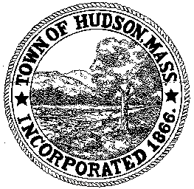

CONSERVATION COMMISSION
78 Main Street, Hudson, MA 01749
(978) 562-2020

Paul Byrne, Chairman W. Minot Wood, Vice Chairman David Esteves, Member

Terrence Joyce, Member Leif Longtine, Member Joseph Rodrigues, Member Al Tashian, Member

Meeting Agenda
July 22, 2010
7:00 P.M.

- Preliminaries
  - Open Meeting
  - Roll Call

2.0 Executive Session for the purpose of discussing potential litigation

3.0 Adjournment

